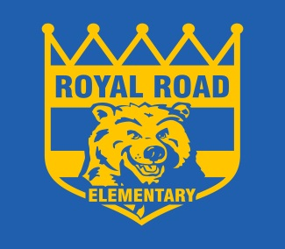
ROYAL ROAD ELEMENTARY SCHOOL
340 Royal Road, Fredericton, NB, E3G 6J9
http://royalroad.nbed.nb.ca
PHONE: (506) 453-5438
FAX: (506) 444-5268
Sheila Legere Principal
Mary Brophy Vice- Principal
To Learn, To Grow, To Lead
November 29, 2019
Dear Parent/Guardian,

Royal Road Elementary School will be participating in an online school perception survey for students called the OurSCHOOL Student Survey. Please find the details of the survey implementation below.

Who: Grade 4 & 5 students
When: December 2nd, 3rd and 4th
Where: Royal Road Elementary School
Why: to measure student engagement, increase student involvement & sense of belonging at school

About the OurSCHOOL Student Survey:
- Allows students to share their feedback anonymously on their experiences at school, school environment, and school improvement programs.
- Based on their feedback, students have the opportunity to be involved in action plans fostering increased student engagement
- Participation in the survey is voluntary, however, all students are encouraged to participate.
- The time required to complete the survey may vary, but it is designed to be completed in approximately 35-40 minutes.
- Please also take a moment to review the attached information which describes the wording adopted by the Department when asking students to identify their gender. This wording is in keeping with human rights legislation and best practices for inclusion.

Survey measures include such topics as behaviours and attitudes linked to student success, emotional and social well-being and physical health. For more information about the OurSCHOOL Student Survey, please visit The Learning Bar’s website: www.thelearningbar.com.

If you have questions or would like to request more information about Royal Road Elementary School’s upcoming implementation of the OurSCHOOL Student Survey, please contact Department of Education and Early Childhood Development at edcommunication@gnb.ca or Mary Brophy at mary.brophy@nbed.nb.ca .

Thank you

Mary Brophy
Vice Principal

